

Practices for Secure Software Report

Table of Contents
Document Revision History 3
Client 3
Instructions 3
Developer 4
1. Algorithm Cipher 4
2. Certificate Generation 4
3. Deploy Cipher 4
4. Secure Communications 4
5. Secondary Testing 4
6. Functional Testing 4
7. Summary 4
8. Industry Standard Best Practices 4

Document Revision History

Version | Date | Author | Comments
1.0 | September 7, 2026 | Cameron Price | Initial submission

Client



Instructions

Submit this completed practices for secure software report. Replace the bracketed text with the relevant information. You must document your process for writing secure communications and refactoring code that complies with software security testing protocols.

- Respond to the steps outlined below and include your findings.
- Respond using your own words. You may also choose to include images or supporting materials. If you include them, make certain to insert them in all the relevant locations in the document.
- Refer to the Project Two Guidelines and Rubric for more detailed instructions about each section of the template.

Developer
Cameron Price

Algorithm Cipher

I recommend AES-256 in Galois/Counter Mode for encrypting data at rest, SHA-256 for checksum and integrity verification, and RSA-2048 or larger for the certificate and key exchange that protects the transport. All three appear in Oracle's Java Security Standard Algorithm Names, so none requires a third party provider, which also removes any reason to keep the 2011 Bouncy Castle library the original code base depended on.
At a high level, an encryption algorithm cipher is a defined procedure that transforms readable data into ciphertext under the control of a key, such that the transformation is reversible only with that key. A hash function is different in kind rather than in degree: it is deliberately one way, mapping input of any length to a fixed length digest that cannot be reversed. Encryption protects confidentiality. Hashing protects integrity. This application needs both, which is why the recommendation names both.
On hash functions and bit levels, SHA-256 produces a 256 bit digest and offers roughly 128 bits of collision resistance under the birthday bound. That is the number that matters for a checksum, because the attack that breaks a checksum is finding two inputs with the same digest. MD5 and SHA-1 both fail this test in practice, MD5 since 2004 and SHA-1 since the 2017 SHAttered demonstration, so neither is acceptable despite both still being offered by the standard library. AES-256 uses a 256 bit key across 14 rounds, and its 256 bit length was chosen here partly for margin against Grover's algorithm, which would halve the effective strength of a symmetric key on a sufficiently large quantum computer.
On random numbers, symmetric versus asymmetric keys, and how they combine: every key and every initialization vector must come from a cryptographically secure source, meaning java.security.SecureRandom rather than java.util.Random, because a predictable key defeats the cipher entirely regardless of its strength. GCM in particular requires a unique IV per encryption under a given key, and reusing one breaks the mode catastrophically. Symmetric encryption uses one shared key and is fast, which suits bulk data. Asymmetric encryption uses a mathematically linked public and private key pair, is far slower, and suits small payloads. Real systems use both: TLS performs an asymmetric handshake to authenticate the server and agree a symmetric session key, then encrypts the actual traffic symmetrically.
On history and current state, the Data Encryption Standard was adopted in 1977 with a 56 bit key and was brute forced publicly by 1998, which is what prompted the competition that produced AES, standardized as FIPS 197 in 2001. Triple DES extended DES's life and is now deprecated. RSA, published in 1977, remains in wide use but has grown key sizes over time and is steadily being displaced by elliptic curve cryptography, which achieves comparable strength with much smaller keys. On the hashing side MD5 gave way to SHA-1 and SHA-1 to SHA-2, with SHA-3 standardized in 2015 as a structurally different backup. The current direction is post-quantum: NIST standardized its first post-quantum algorithms in 2024, which matters most for data with a long confidentiality lifetime, exactly like financial archives.

Certificate Generation

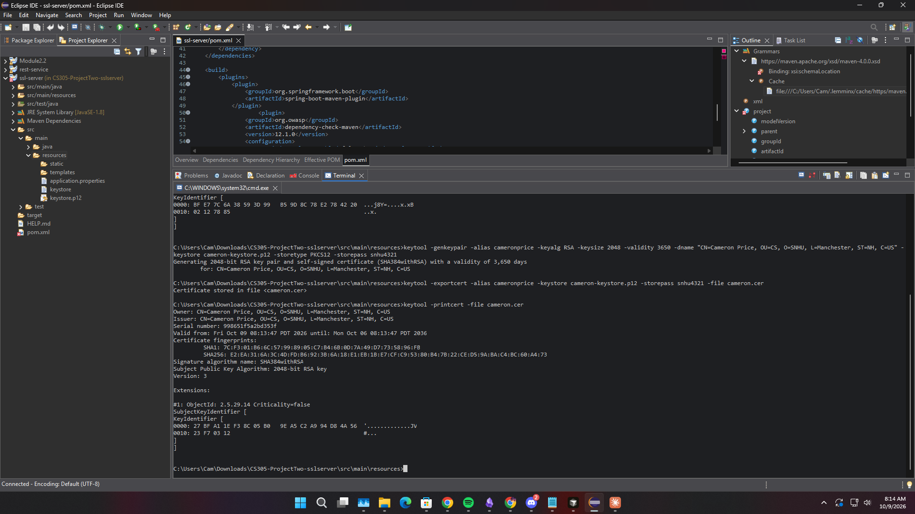

Deploy Cipher



Secure Communications

Secondary Testing

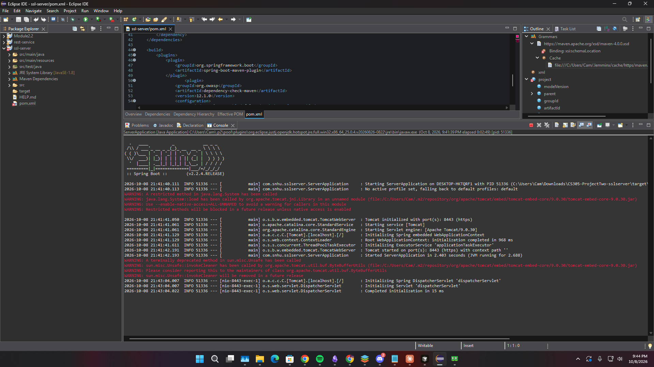
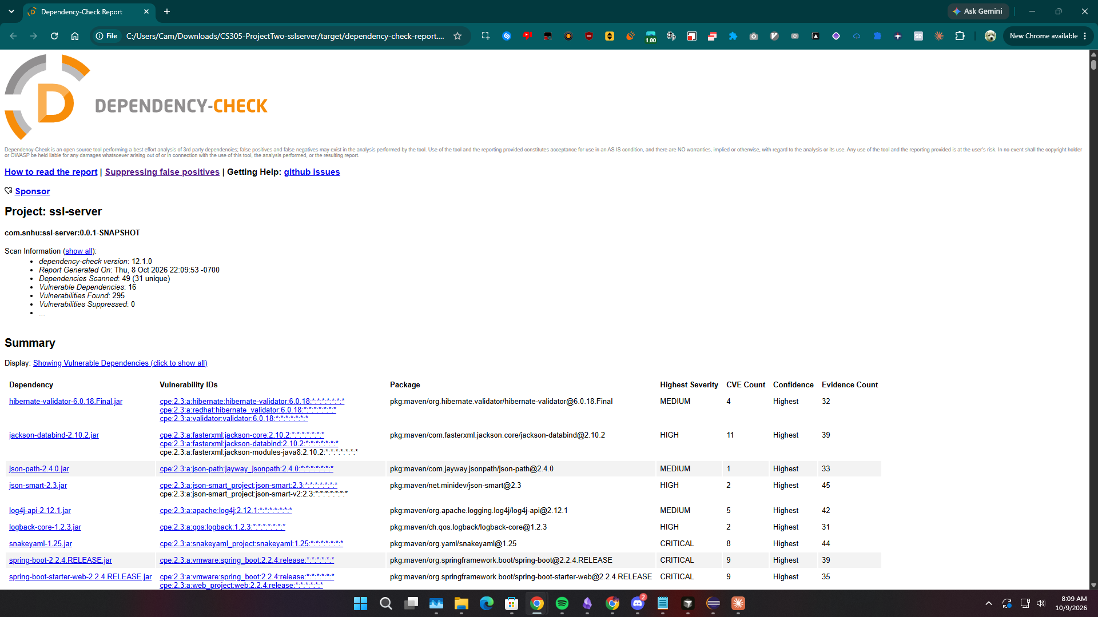

Functional Testing

Summary

The refactoring addressed the vulnerabilities identified in the Project One assessment along three lines. First, a cryptographic hash function was deployed: the /hash route now computes a SHA-256 digest over a unique data string and returns the algorithm name and the hexadecimal checksum, so a client can verify that what they received is what was published. The charset is stated explicitly as UTF-8 rather than left to the platform default, because the same text under a different encoding produces a different digest and a checksum that varies by machine is not a checksum.
Second, the transport was secured. A self-signed certificate was generated with the Java keytool and the application was configured through server.ssl properties to serve HTTPS on port 8443, so the checksum route and everything else are no longer served in cleartext. It is worth stating plainly that the keystore password sitting in application.properties is acceptable for a self-signed classroom certificate and would not be acceptable in production, where it belongs in an environment variable or a secret store.
Third, secondary testing confirmed that the refactoring did not introduce new problems. The OWASP dependency-check plug-in was run again after the changes and the report compared against the earlier one, and the JUnit suite was executed to confirm the application still builds and runs. That second step is the one most easily skipped and the one that matters: a security fix that breaks functionality gets reverted, and a refactor that adds a vulnerable dependency has moved the problem rather than solved it.

Industry Standard Best Practices

The industry standard practices that guided this work reduce to a few rules that were applied concretely rather than cited abstractly. Use standard, published, widely reviewed algorithms rather than anything custom, which is why every algorithm named here comes from Oracle's standard names list. Never hardcode a secret, which was the single worst finding in the original assessment. Encrypt in transit and at rest, since protecting one and not the other leaves the data readable somewhere. Validate all input at the boundary and use parameterized queries so untrusted data can never become executable. Apply least privilege so a compromise is contained rather than total.
Two practices deserve emphasis because they are process rather than code. Dependencies must be inventoried and scanned continuously, not once, because the code you wrote is a minority of what you ship and a library that was clean last quarter may have a published CVE today. And every security change must be verified rather than assumed: run the scan again, run the tests again, and compare the reports. In my own work in vulnerability management, applying a fix and proving the finding is gone are treated as two different claims, and only the second one is worth writing down.

